Curriculum Frameworks
At Fred Nicholson School, all our pupils have an Educational, Health and Care Plan. Therefore our curriculum has been designed around the key areas and outcomes of this plan. These five frameworks are covered within all of our curriculum pathways:
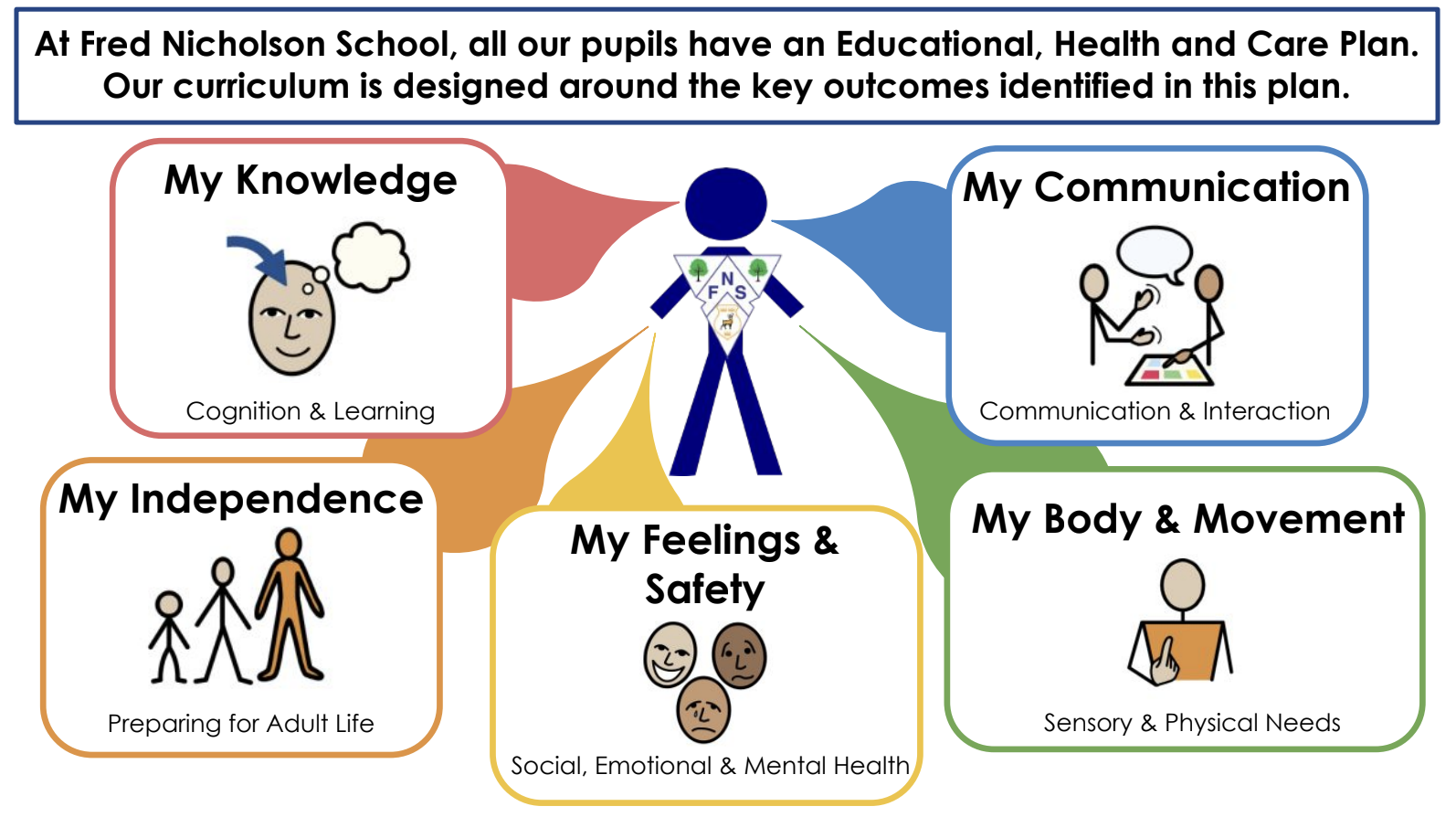

Curriculum Strands
Within each framework, the curriculum content is broken down into Curriculum Strands. These are the ‘subjects’ that make up our programme of study at Fred Nicholson School:
NOTE FOR WEBSITE: PLEASE ADD LINKS TO CURRICULUM OVERVIEWS FOR THE RELEVANT STRANDS – SEE SEPARATE FOLDER

Curriculum Framework | Curriculum Strands
My Knowledge | - Functional Maths  - Written Communication  - Early Reading  - World Around Us  - People and Communities
My Communication | - Speech, Language and Alternative Communication  - Digital Communication  - Attention Autism
My Body & Movement | - Physical Activity  - Swimming  - Hydrotherapy  - Creative Learning  - Outdoor Learning
My Feelings & Safety | - Personal, Social, Health and Economic Education (PSHE)  - Zones of Regulation
My Independence | - Life Skills  - Cooking for Life  - Careers & Employability  - Ready 2 Go

The main content of our curriculum is based on aspects of the following frameworks and approaches:

- The Early Years Foundation Stage Framework
- The Engagement Model
- Functional Skills Qualifications
- Zones of Regulation
- Attention Autism
- Learning Outside the Classroom
- Forest School
- Sensory Circuits
- Hydrotherapy
- Trauma Informed Schools UK
- TITAN Travel Training
- Gatsby Career Benchmarks

Where relevant and appropriate to individual cohorts of learners, our curriculum also includes aspects of the National Curriculum Framework. However, the identified core and foundation ‘subjects’ within the framework have been adapted into our curriculum strands to ensure they are purposeful and relevant to our cohort.

Spiritual, Moral, Social and Cultural Development
Our school provides a context for spiritual, moral, social and cultural learning and experiences. Pupils will have the opportunity to experience different aspects of society within a clear and consistent moral framework developing mutual respect and tolerance for each other. Our young people are given opportunities to make informed choices to develop leadership skills, to take responsibility and to consider the consequences of their actions now and in the future.
These aspects are embedded across the curriculum, recognising and reinforcing core British values and our school values:

British Values
The government set out its definition of British values in the ‘Prevent Strategy’. These values include:
- Democracy
- The rule of law
- Individual liberty
- Mutual respect
- Tolerance of those of different faiths and beliefs

Our School Values

Our pupils are:

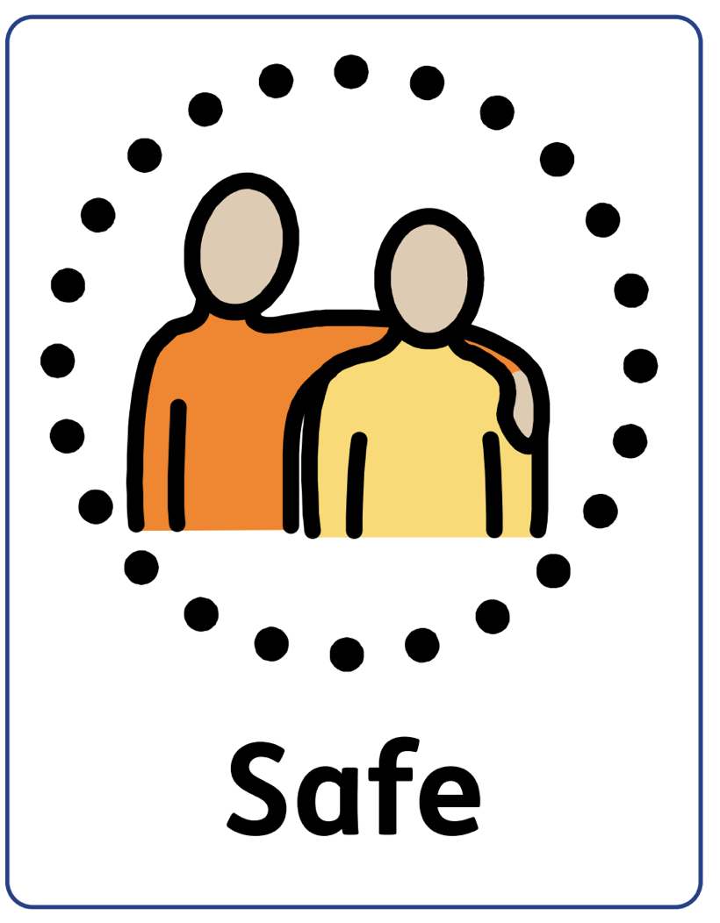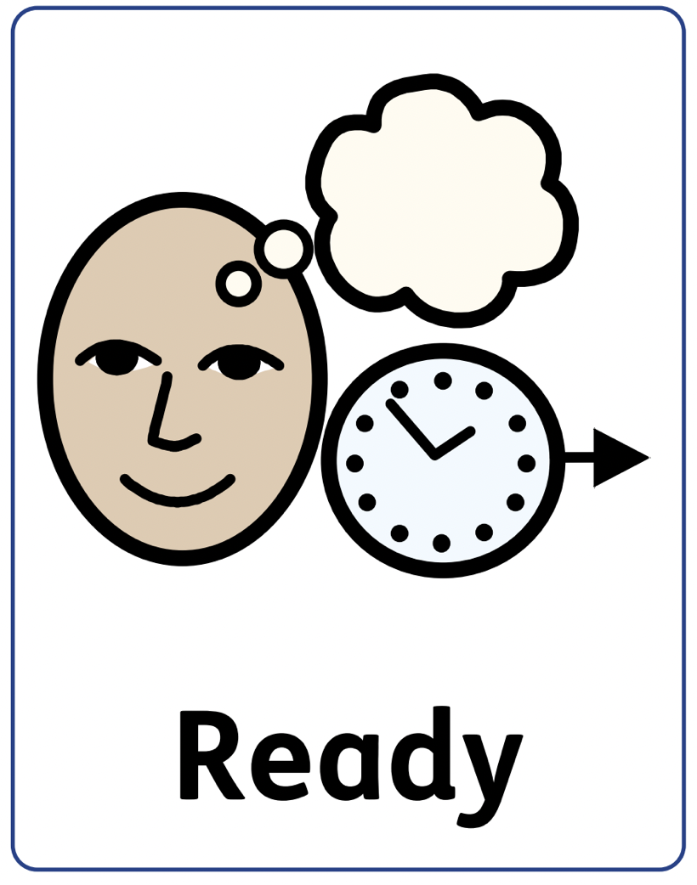

Safe: we self-regulate to look after ourselves, others and our school

Ready: we are prepared and open to learning

Respectful: we think of others, we show empathy, patience and kindness

